Images for **Infrastructures for Digital Research: New opportunities and challenges**

**Lorna Hughes**

**Figure 1: Homepage, Welsh Newspapers Online**

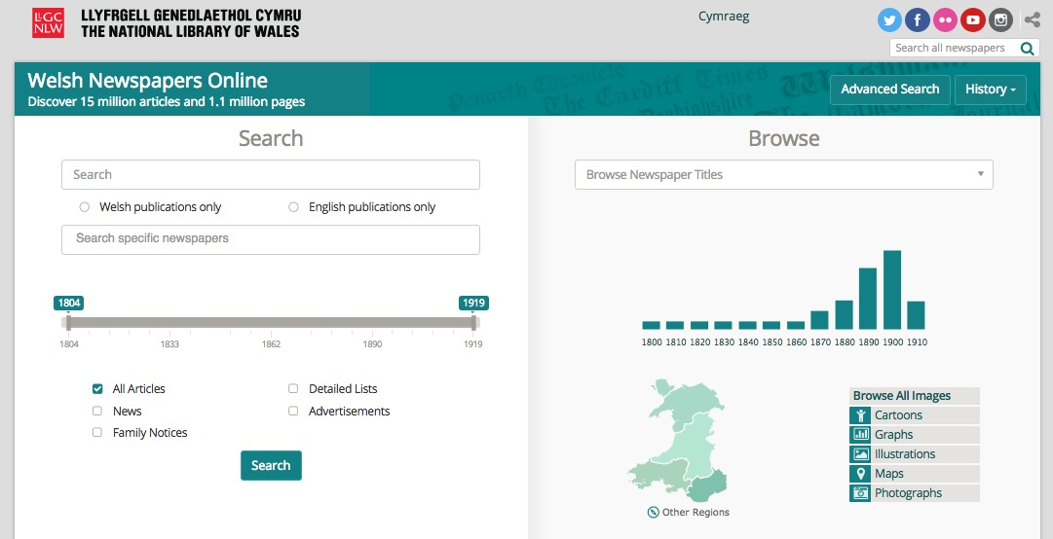

**Figure 2**

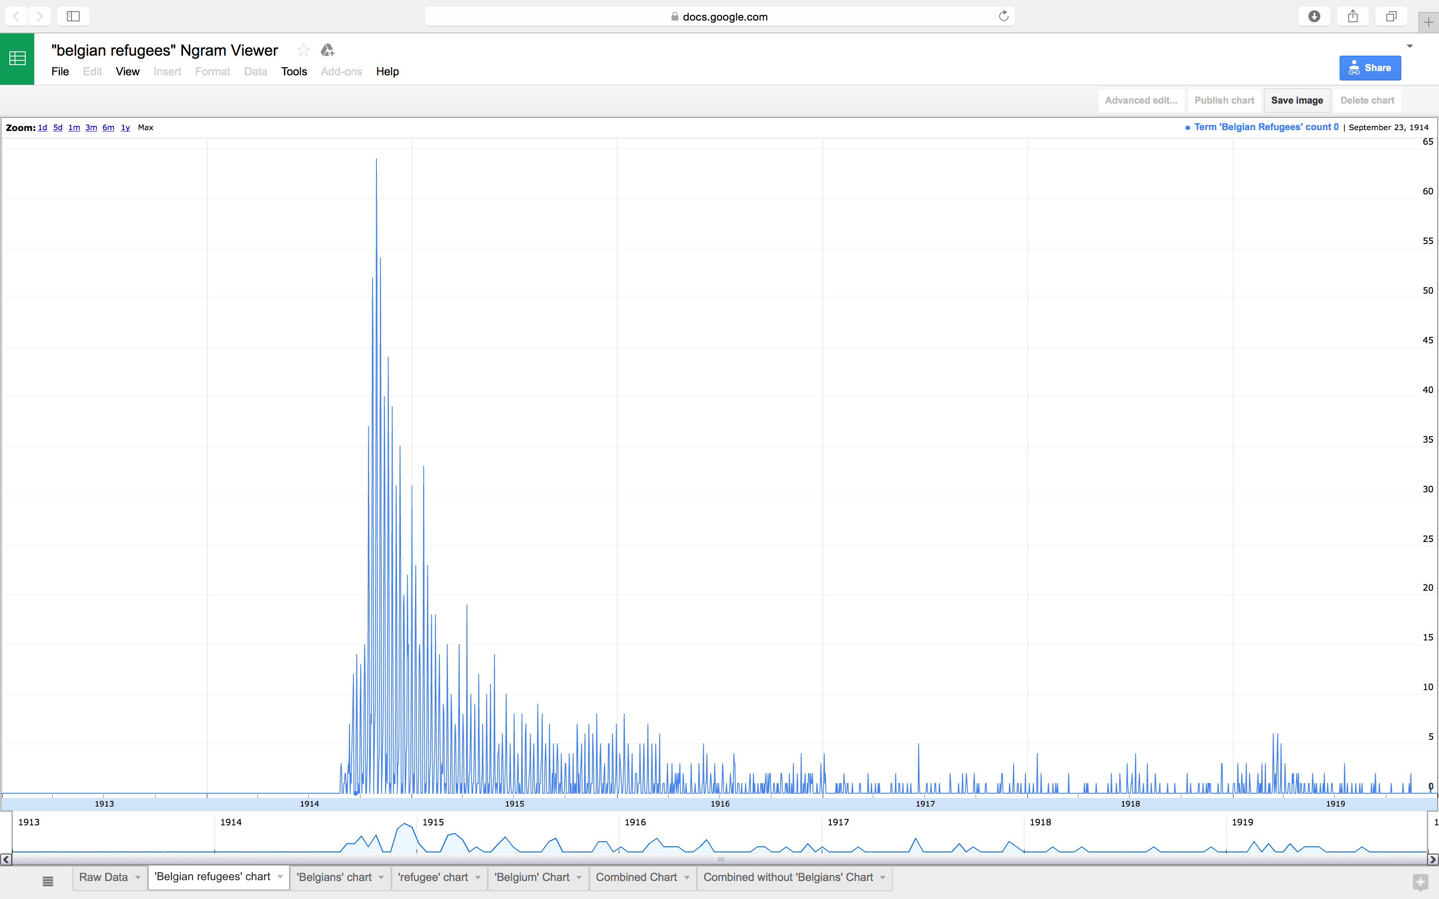

**Figure 3**

